**LAPORAN UJIAN TENGAH SEMESTER**

Tugas ini untuk memenuhi salah satu tugas UTS

Mata Kuliah Pemrograman Berbasis Web

**Dosen Pengampu : H. Bagja Nugraha, S.T., M.Kom**





**Disusun Oleh :**

Nama : Chandra Christian

NPM : 2110631250035

Kelas : 4B

**Program Studi Sistem Informasi**

**Fakultas Ilmu Komputer**

**Universitas Singaperbangsa Karawang**

**2023**

**Coding HTML dan CSS**

* **HTML**
  + **HOME**

* + **ABOUT ME**

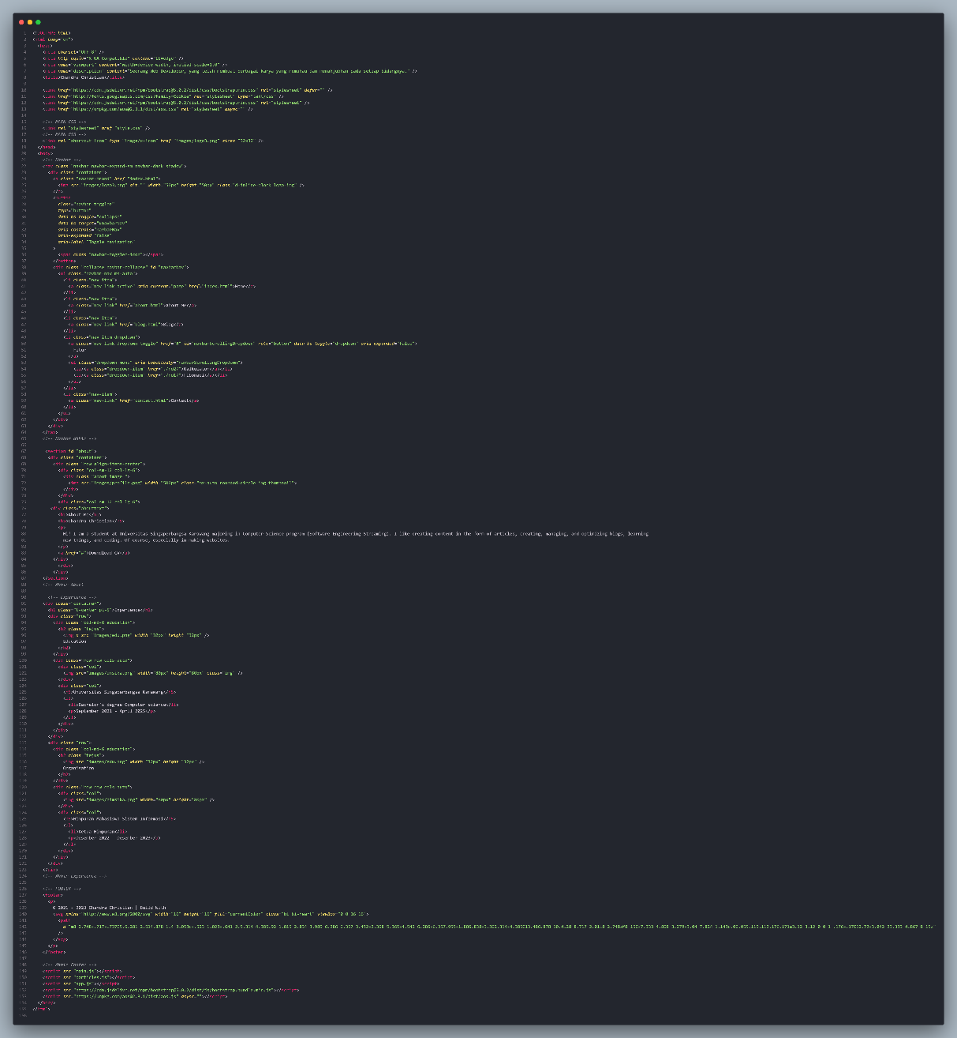

* + **BLOG**

* + **FITUR**
    - **CALCULATOR**

* + - **FIBONACI**

* + **CONTACT**

* **CSS**

* **JS**

* **Hasil Website**
  + **HOME**

* + **ABOUT ME**

* + **BLOG**

* + **FITUR**
    - **CALCULATOR**

* + - **FIBONACI**

* + **CONTACT**

